MedFriend: Medication Reminders

# Product Summary

## The Problem

One study in the USA found that 75% of adults do not adhere to medication prescriptions. People forget. This costs an estimated $100 billion annually in the USA alone. Smart reminders to help people remember medication means better health, and a better economy.

## The Solution

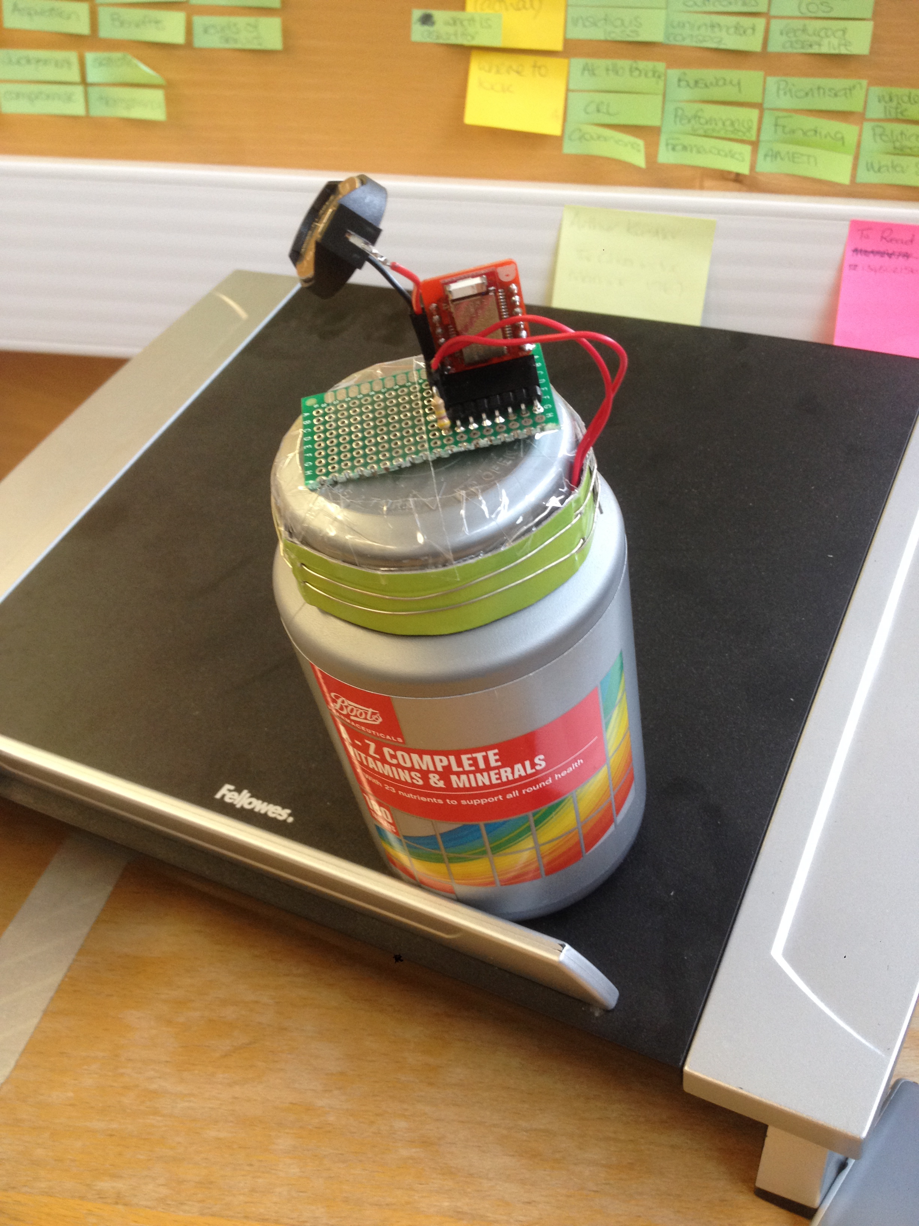MedFriend is a smart device using Bluetooth Low Energy (BLE) technology to sense when a medication bottle is opened. Depending on user choice, it can send alerts when:

* Medication hasn’t been opened by a certain time; and
* A container with potentially dangerous contents is opened.

Users interact with MedFriend through a simple mobile app to track their medication bottles, set reminders, and set alerts.

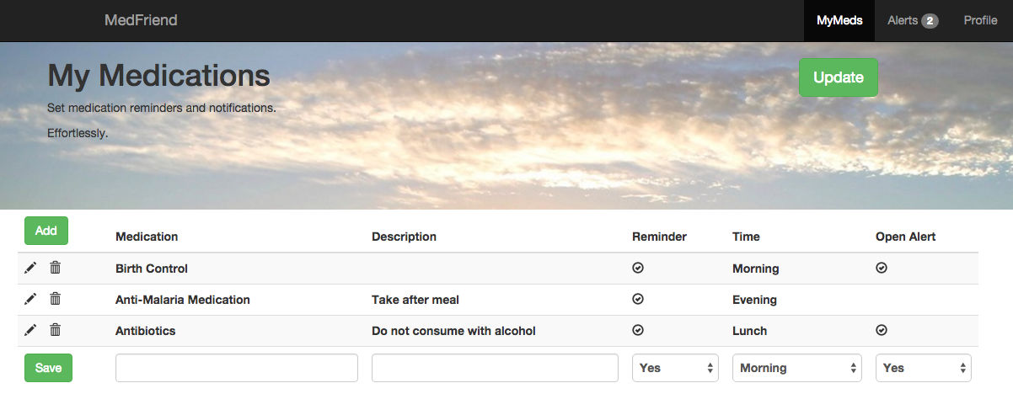

## Further Opportunities

MedFriend can be extended to track medication bottles in multiple locations by using local routers gather BLE signals and transmit them via a mobile network. This could further allow:

1. Helping care for loved ones by ensuring they take medication as prescribed;
2. Helping physicians track patient adherence to prescriptions; and
3. Helping researchers conduct medical studies.

# Sensor Design

Throughout the project, three main sensor designs were experimented. The goal was to detect the opening of the bottle. In the end, the KISS (Keep it simple, stupid!) approach delivered the best performance.

### #1 - Magnetic reed sensor attached to the side of the bottle and one or more magnets attached to the lid, close to its edges

This approach seemed to work at first, as opening and closing the lid would cause a rotation of the magnet past the reed sensor. However, a misalignment of just a few millimetres between the magnet and the reed sensor caused a non-triggering of the sensor, due to the limited range of action of the magnet. Moreover, closing the lid in some ways (for example, when it is not require to rotate it by 360°) caused the magnet not even to pass close to the reed sensor, not triggering it.

### #2 – Graphite patterns conductivity check

Trying to simplify things, the conductivity of skin was exploited to create a current between two conductors, giving rise to a signal. This was put in series with a 470kΩ resistor and the potential of the middle point of the obtained voltage divider was measured with an AnalogInput pin (the input would then read a lower value when the contacts were opened and a higher value when they were closed). In order to achieve this, a strip of paper to wrap around the lid with two paths of conductive ink would have been the ideal set up. However, in absence of it, heavy pencil mark was used. This performed well at first, but as grease from the user's skin was depositing on the graphite, the strip would effectively lose its conductivity, making it impossible to use the sensor.

**

*Graphite pattern wrapped around the lid. Opening the bottle with one's fingers will unavoidably create a contact between the two paths.*

#3 – Conductivity check with two conductive wires around the lid

Taking the KISS approach to an extreme, the graphite patterns were replaced with two parallel bare metal wires, in such a way that the user would create an electrical contact between them. The circuit set up was the same as with the graphite patterns. This method proved to be the most effective, outperforming the other two for consistency and reliability.

# Challenges

Despite all the fun we have had in the project, we have also encountered a few technical difficulties in the process. Often, some libraries provided by third party (including ARM) are not sufficiently documented, which requires us to experiment with some of the methods and classes. Also, the board has a limited number of pins, which restricts our possibilities to extend its functionalities and to debug it (which may also be improved by adding a physical reset button to the board itself).

Although the new yotta develop platform has its own advantages of being easier to manage and edit, some of its incompatibilities with the old MBed platform has caused some confusions. With the new platform, checking documentations of third-party compilers are not as straightforward as it is with the old online ide. Some out-dated official documentations have also caused some confusions in the development process, along with some not yet ported C/C++ standard libraries. For example, ctime did not work for the board. As the code structure has also deviated slightly from the normal C/C++ code structure, it is not fully understood, and may have resulted in some unexplained behaviour of certain pieces of codes.

# Team Members

Bill Jia – [bzj20@cam.ac.uk](mailto:bzj20@cam.ac.uk)

Luca Donini – [ld492@cam.ac.uk](mailto:ld492@cam.ac.uk)

Duncan McNicholl – [drm60@cam.ac.uk](mailto:drm60@cam.ac.uk)

Edgar Gu – [zg245@cam.ac.uk](mailto:zg245@cam.ac.uk)